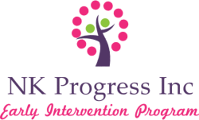

DRUG/ALCOHOL ABUSE DISCLAIMER

I am not addicted or dependent on any illegal drugs or alcohol.

My ability to adequately care for patients is not impaired in any way.

Therapist Name (Print): ________________________________

Signature: ________________________________

Date: ________________________________

